[Check if you already have Java](https://phoenixnap.com/kb/check-java-version-linux" \t "_blank) installed on your Ubuntu system:

java -version

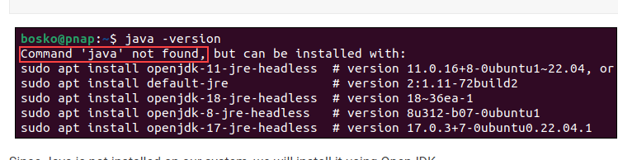

 First, open a terminal window and update the system package repository by running:

sudo apt upgrade

* To install OpenJDK 11, run:

sudo apt install openjdk-11-jdk -y

**Add Jenkins Repository**

Start by importing the GPG key. The GPG key verifies package integrity but there is no output. Run:

curl -fsSL https://pkg.jenkins.io/debian-stable/jenkins.io.key | sudo tee /usr/share/keyrings/jenkins-keyring.asc > /dev/null

2. Add the Jenkins software repository to the source list and provide the authentication key:

echo deb [signed-by=/usr/share/keyrings/jenkins-keyring.asc] https://pkg.jenkins.io/debian-stable binary/ | sudo tee /etc/apt/sources.list.d/jenkins.list > /dev/null

## Install Jenkins

1. Update the system repository one more time. Updating refreshes the cache and makes the system aware of the new Jenkins repository.

sudo apt update

2. Install Jenkins by running:

sudo apt install Jenkins -y

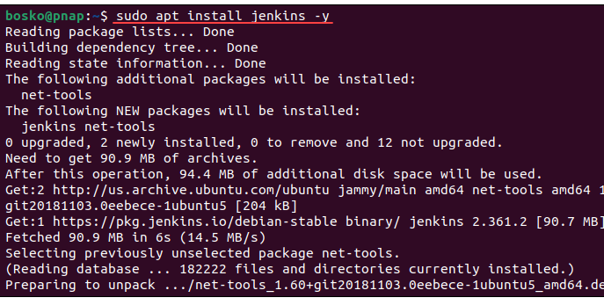

sudo systemctl status Jenkins

